MCW NEWS FROM THE DESK OF GEORGE MCDERMOTT
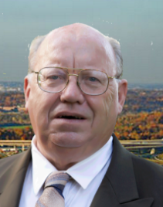
REPORTING on Corporate, Financial & Judicial Crimes against our organic Constitution and
Our United States of America, 143 N. Huron Dr., Forest Heights, MD 20745 phone 301-996-9577.
Email @ Georgemcdermott2018@.gmail com, website secretjustice.com also GeorgeMcDermott.com

December 17, 2019

Hon. Congressman Jerrold Nadler
Chairman House Judiciary Committee
R. 2138 Rayburn HOB.
Washington D.C. 2515 Hand-Delivered Due To The Importance Of The Content

Chairman Nadler, I come to you and your other 39 colleagues on the House Judiciary Committee as guardians of our Constitution and rule of law and also as the legislative branch of our government that has impeachment powers over the executive and judicial branches of government when they stray from the rule of law and our Constitution. Your committee is about to vote on the exercise of its impeachment of an elected president whose history will be record for future generations as to whether the executive branch of government and our president has met the threshold of high crimes and misdemeanors called for under our Constitution and rule of law. The nations’ prayers are with every member of your committee on both sides, in your upcoming vote and exercise of your legal duties and responsibilities. You should know our nations prayers are with you and all the other panel members at this time. May God be with your findings.
1 Secondly, as the panel has demonstrated in these impeachment proceedings, the rule of law and our Constitution also gives your panel and the full Congress the ability to investigate high crimes and misdemeanors against those holding government offices, including the Judiciary, to be true to their oath of office and their employment contracts and have full faith and allegiance to the Constitution of these United States of America. However, I come to you today to report as I am required to under 18 USC 2382 acts of treason, which I have personally witnessed in our court systems, state and federal, and have asked that your committee look into and investigate. The corruption within our state and federal judicial branches of government which now appears to go into the office of the DRG OIG’s office, the FBI’s OIG’s office, where these agents are not providing honest services to our citizens, by failing to protect our citizens from attacks by corporate insiders protecting fellow bar members, over their oath of office and citizens civil rights, also I have included is my affidavit of truth as to my assertions. See secretjustice.com programs 1400 through 1426 which attest to the sad state of our state and federal court system. I’ve done my duty in reporting this abuse of power and law to courts superiors.[E-1]
2. Finally all members of the House Judiciary Committee , I’m asking if anyone can clarify a point of law as to the jurisdiction of our State and Federal Court systems regarding through whom they owed their loyalty to and allegiance to, as public servants. If anyone in the committee or any other staff members care to answer the question which is apparently published public knowledge and supported by historic documents that the predecessors in the Congress of yours turned over all laws United States to the control of the UN based on public laws recorded as of December 26, 1933, 49 Statute 3097 Treaty Series 881 ( Convention on Rights and Duties of States) stated CONGRESS replaced STATUTES with international law, placing all STATES under international law on December 9, 1945, the International Organization Immunities ACT RELINQUISHED EVERY PUBLIC OFFICE OF UNITED States to United Nations. 22 CFR 92.12-92.31 FR Heading "Foreign Relationship" states that an oath is required to take office. See full text at [E – 2]. Is our organic Constitution still law? Or have we we the citizens of this nation been deceived by our leadership acting as a shadow government protecting only corporate banking interest, protected by the American Bar Association’s monopoly on our courts? I will await your response.
Respectfully submitted

George Edward McDermott
[E – 1]. Notarized affidavit of truth as to the treasonous acts of judges against Lori Saxon pages 2 – 4
[E – 2]. Memorandum of law as to paragraph 2 Question. Are We Under UN Control Or Not pages 5 – 6

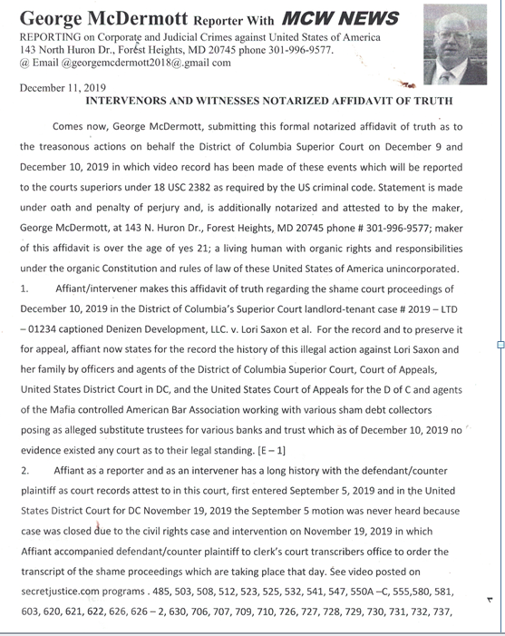
Petitioner prays that this panel member and his colleagues will investigate the out-of-control abuse of power and abuse of office by court insiders and corporate America's agents and assigns working to steal citizens Lori Saxon's home and equal access to our nations courts as chronicled@
secret justice.com and George McDermott.com 1500+ videos supporting petitioner's claim
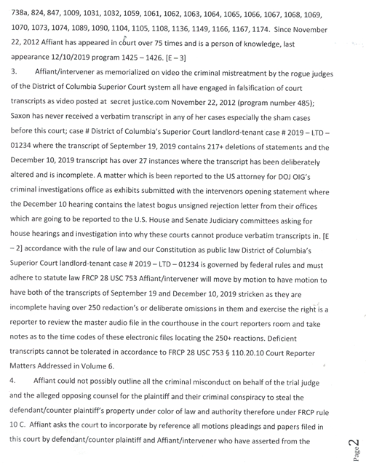
For the benefit of this panel member and his 39 colleagues in the House Judiciary Committee petitioner has 1500+ videos showing treason against the Constitution and fraud on the court by state and federal judges which the DOJ/OIG's office and the FBI/OIG's office illegally claim they have no jurisdiction to prevent or investigate waste fraud and abuse by our totally corrupt judicial system which appears to be filled with foreign agents, judges, and ABA members, subverting the rule of law and Constitution see 18 USC rule 4 and 2382 . Petitioner has complied with reporting requirements

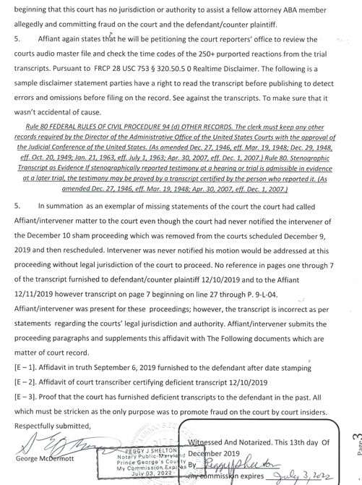
Surely the judiciary committee in its panel members are aware that 70% of the foreclosures in the United States of America from 2006 through 2019 have been accomplished with forged falsified deeds of trust, orders to docket, and falsified affidavits notarized and placed into the record with knowingly false signatures of alleged debt collectors their agents and assigns. As in Lori Saxon's case.
FIRST PUBLISHED BY ADAM ROBINSON‎ TO DEMOCRACY NOW! JULY 6, 2015 · ALL SEATS OF GOVERNMENT HAVE BEEN VACATED. (Can these truisms be verified)
A. December 26, 1933 49 Statute 3097 Treaty Series 881 ( Convention on Rights and Duties of States ) stated CONGRESS replaced STATUTES with international law, placing all STATES under international law. (Question # 1.Can the panel member or his staff verified treaties existence and location).

B. December 9, 1945, the International Organization Immunities Act relinquished every public office of United States to United Nations. (Question # 2.Can the panel member or his staff verified treaties existence of executed documents and location).

C. Title 8 USC 1481 states once an oath of office is taken, citizenship is relinquished, thus one becomes a foreign entity, agency, or state. That means every public office is a foreign state, including all political subdivisions. (i.e. every single court is considered a separate foreign entity). (Question # 1.Can the panel member or his staff Verified this published fact asserted).

D.Title 22 USC (Foreign relations and Intercourse) Chapter 11 identifies all public officials as foreign agents. (Question # 3. can the panel member or his staff verified treaties existence and location).
Title 28 USC 3002 Section 15A states United States is a Federal Corporation and not a government, including the Judicial Procedural Section. Federal Rules of Civil Procedure (FRCP) 4j states that the Court jurisdiction and immunity fall under a foreign state. (Question # 4.Can the panel member or his staff Verified this published fact asserted).

E. As the The 11th Amendment states "The Judicial power of the United States shall not be construed to extend to any suit in law or equity, commenced or prosecuted against one of the United States by Citizens of another State, or by Citizens or Subjects of a Foreign State." (A foreign entity, agency, or state cannot bring any suit against a United States citizen without abiding the following procedure.)
Title 22 CFR 93.1-93.2 states that the Department of State has to be notified of any suit, and in turn has to notify the United States citizen of said suit. (Question # 5.Can the panel member affirm or deny this is a requirement under our organic Constitution not shadow government. United States, Inc. and its inside corporate agents)

F. Title 28 USC 1330 states that the United States District Court has to grant permission for the suit to be pursued once the court has been supplied sufficient proof that the United States citizen is actually a corporate entity.Title 28 USC 1608 One has Absolute Immunity as a Corporation.Title 28 USC 1602-1611 ( Foreign Sovereign Immunities Act ) allows the jurisdiction of a court to be challenged, and a demand of proper jurisdiction to be stated. July 27, 1868, 15 Statutes at Large Chapter 249 Section 1 "Acts Concerning American Citizens in a Foreign State," expatriation, is what is broken when jurisdiction is demanded, and is not met with an answer. (Question # 6. Can the panel member confirm or deny these statutes supersede the organic Constitution/rule of law)

G. Under the Federal Rules of Civil Procedure 12b 6, the prosecution has failed to provide adequate proof that the parties involved in this situation are actually corporate entities. And There is ample proof that the prosecution and other agents are actually authorized corporations and agents
(Question # 7.Can the panel member and or its staff identified corporate affiliation).
H. In 1950, the 81st Congress investigated the Lawyers Guild and determined that the B.A.R. Association is founded and run by communists under definition. Thus, any elected official that is a member of the B.A.R. will only be loyal to the B.A.R. and not the people. In 1933, elected officials and the alleged "country" have been given to the United Nations Government "That the Pan American treaty of 12-26-1933 (49 STAT 3097) Treaty Series 881 – (Convention on Rights and Duties of States) stated CONGRESS replaced STATUTES with international law, placing all states under international law. (Question # 8.Can the panel member affirm or deny treaty was properly ratified)

I.That the International Organization Immunities Act of 12-9-1945 – - Congress relinquished every public office over to the UN. Local governments up to the president fall under UN jurisdiction. Congress gave the UN the right to dictate what laws will be international & gave them the right to tax the States. That the International Reorganization Rescind Act- Congress put this into form but they never took action to rescind the act. Fairly recently an Ohio judge filed suit claiming that Congress did not have the right to relinquish government authority over to the UN (a corporation or foreign country) and that the Congressional act was a constitutional violation because they didn’t put it to the States or the people to agree on it. (Question # 8.Can the panel member affirm or deny the awareness of these cases and corresponding case numbers also was the denial signed by judge.

J. Is the panel member aware that In 2005 the US Supreme court declined to hear the case therefore all public offices are under UN jurisdiction & they are not American Citizens.
That the Oath of Office – Title 5 USC 331, 332, 333 backed up by Title 22 CFR Foreign Relations 92.12 – 92.31 and Title 8 USC, section 1481 – the public official relinquishes his national citizenship and are thus foreign agents as stipulated under Title 22 USC, chapter 11, section 611, loss of national citizenship – Public officials are no longer US Citizens, but rather are foreign agents and must register as such. (Question # 9.Can the panel member affirm or deny
J. That Title 8 USC 1481 stated once an oath of office is taken citizenship is relinquished, thus you become a foreign entity, agency, or state. That means every public office is a foreign state, including all political subdivisions. (i.e. every single court is considered a separate foreign entity).
That Title 22 USC (Foreign Relations and Intercourse) Chapter 11 identifies all public officials as foreign agents. That Title 28 USC 3002 Section 15A states that the United States is a Federal Corporation and not a Government, including the Judiciary Procedural Section. (Question # 10.Can the panel member affirm or deny statute law above has been ratified and is law)

L. Further That the Federal Rules of Civil Procedure (FRCP) 4j states that the Court jurisdiction and immunity fall under a foreign State. As published in US code title 28 USC CHAPTER 176 - FEDERAL DEBT COLLECTION PROCEDURE. The Federal Debt Collection Procedure places all courts under equity and commerce and under the International Monetary Fund." (Question # 11.Can the panel member affirm or deny that title 15§§1692 protect citizens rights in all courts).
M. Further That in 1950 81st Congress investigated the Lawyers Guild and determined that the B.A.R. Association is founded and run by communists under definition. Thus any elected official that is a
member of the B.A.R. will only be loyal to the B.A.R. and not the people.That the Oath of Office – Title 5 USC 331, 332, 333 backed up by Title 22 CFR Foreign Relations 92.12 – 92.31 and Title 8 USC, section 1481 – the public official relinquishes his national citizenship and are thus foreign agents as stipulated under Title 22 USC, chapter 11, section 611, loss of national citizenship – Public officials are no longer US Citizens, but rather are foreign agents and must register as such. (Question # 11.Can the panel member affirm or deny action was recorded as published)
N. Additionally That Title 8 USC 1481 stated once an oath of office is taken citizenship is relinquished, thus you become a foreign entity, agency, or state. That means every public office is a foreign state, including all political subdivisions. (i.e. every single court is considered a separate foreign entity).
That Title 22 USC (Foreign Relations and Intercourse) Chapter 11 identifies all public officials as foreign agents. Title 28 USC 3002 Section 15A states that the United States is a Federal Corporation and not a Government, including the Judiciary Procedural Section. That the Federal Rules of Civil Procedure (FRCP) 4j states that the Court jurisdiction and immunity fall under a foreign State.
(Question # 12.Can the panel member affirm or deny this published law article)

O. Noting That 28 USC CHAPTER 176 - FEDERAL DEBT COLLECTION PROCEDURE.
The Federal Debt Collection Procedure places all courts under equity and commerce and under the International Monetary Fund apparently controls America’s commerce. And courts as described paragraphs A through O is this Congress not acting as a Board of Directors and its president the CEO of the United States, Inc. as a quasi-public corporation under UN and UCC international law.
(Question # 13.Can the panel member affirm or deny a ratified constitutional amendment presented to the ratifying states and public citizens was recorded and in the national archives)

P. That Title 8 USC 1481 stated once an oath of office is taken citizenship is relinquished, thus you become a foreign entity, agency, or state. That means every public office is a foreign state, including all political subdivisions. (i.e. every single court is considered a separate foreign entity).
That Title 22 USC (Foreign Relations and Intercourse) Chapter 11 identifies all public officials as foreign agents. (Question # 14.Can the panel member affirm or deny whether the panel member has surrendered his organic citizenship in the United States of America. Unincorporated or not)

Q. Title 28 USC 3002 Section 15A states that the United States is a Federal Corporation and not a Government, including the Judiciary Procedural Section. That the Federal Rules of Civil Procedure (FRCP) 4j states that the Court jurisdiction and immunity fall under a foreign State. That 28 USC CHAPTER 176 - FEDERAL DEBT COLLECTION PROCEDURE. The Federal Debt Collection Procedure places all courts under equity and commerce and under the International Monetary Fund." The final (Question # 15 is Can the panel member affirm or deny that our citizens are entitled to protections afforded under US code title 15 and international law UCC statutes needed the consent of the ratifying states and votes of citizens)
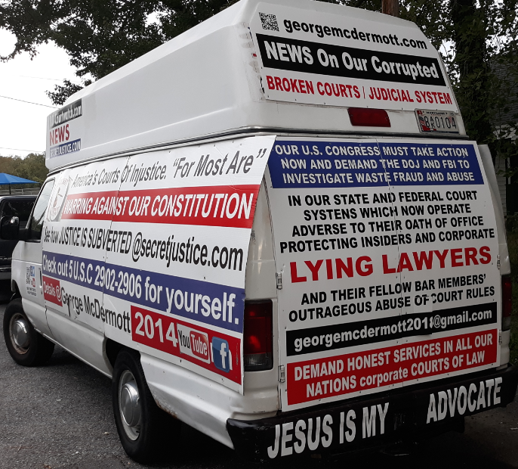
therein).
THE JUDICIARY ACT OF 1789
SEPTEMBER 24, 1789.
1 STAT. 73.
CHAP. XX.–An Act
to Establish
the Judicial Courts
of the United States.
SECTION 1.
Emphasis on our Constitution
our Constitution

